**Experiment 3:**

T Raja Aadhithan

602162021

1. **Write a Shell Script program to find factorial of a number.**

**Code:**

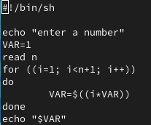

**Output:**

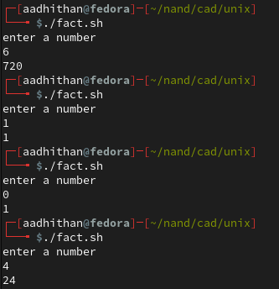

1. **Write a Shell Script program to sort an array in ascending order.**

**Code:**

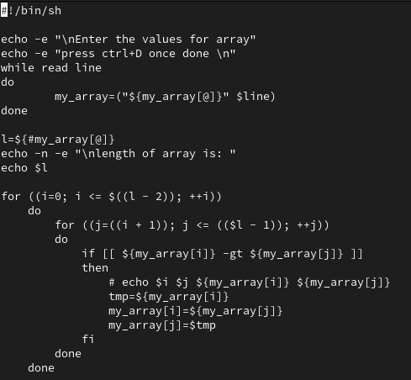

**Output:**

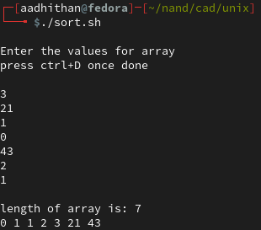

1. **Write a Shell Script program to display list of user currently logged in.**

**Code:**



**Output:**



1. **Write a Shell Script program to display “Hello World”.**

**Code:**



**Output:**



1. **Write a Shell Script program to develop a calculator.**

**Code:**

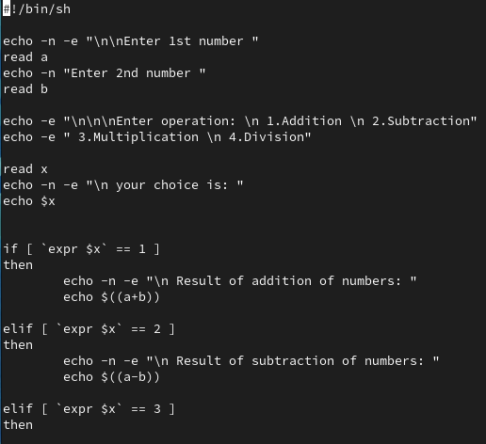

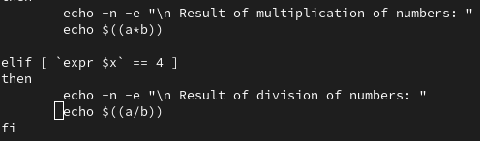

**Output:**

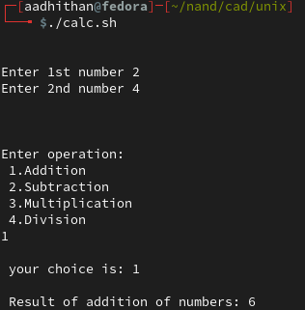

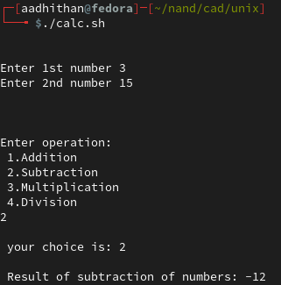

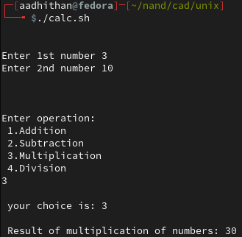

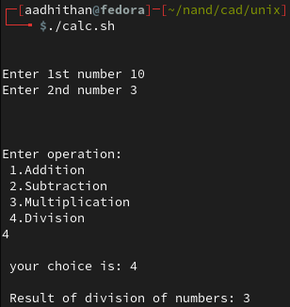

1. **Write a Shell Script program to check whether the given number is even or odd.**

**Code:**

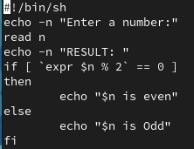

**Output:**

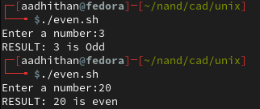

1. **Write a Shell Script program to search whether element is present in the list or not.**

**Code:**

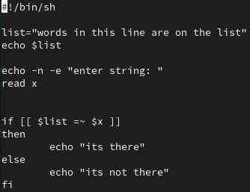

**Output:**

